To make a copy of any microSD card utilized on the Raspberry Pi Zero W (or any other card for that matter), download the Win32 Disk Imager software from the following web address <https://sourceforge.net/projects/win32diskimager/>.

With the software downloaded, you will need to launch the program and insert the microSD card into your computer or laptop. If your machine only has a ‘full-sized’ SD card reader, make sure to utilize an SD card adapter (which should come included with every microSD card package).

If the microSD card utilizes a Linux-based system (as most all Pi projects are), ignore any warnings about the card being unreadable and DO NOT format the card if asked. Simply close any pop ups and continue with this guide.

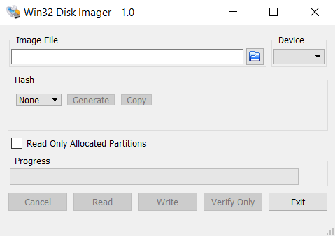

**Figure 1: Program Interface**

Click the blue folder icon to select the location at which a copy of the microSD card’s ‘image’ will be copied to. Next, pick the name of the microSD card in the ‘Device’ dropdown image, then click ‘Read’ at the bottom of the Win32 Disk Imager window. This will copy the ‘image’ from the microSD card to the chosen destination. Warning: this process may take a while to perform and depends largely on the (utilized) size of the SD card’s storage.

To load an ‘image’ to a microSD card, select the location of the originally copied ‘image’ by clicking on the blue folder icon, selecting the new microSD card in the ‘Device’ dropdown. Then clicking ‘Write’ at the bottom of the Win32 Disk Imager window.